|  |  |  |  |  |  |  |  |  |  |  |  |
| --- | --- | --- | --- | --- | --- | --- | --- | --- | --- | --- | --- |
| C:\Users\Eigenaar\Documents\PROVIL\Afbeeldingen - logo's\LOGO PROVIL ION 2.jpg | | | **Course: English**  **TEST: Reading comprehension u3** | | | | | | | | |
| **Teacher:** | | J. Boonen | | **Class** | | 3 WET/ECO | | **Date:** | | | 10/03/2017 |
| **Pupil:** | | Gijs Hoeben | | **Score:** | |  | | |  |  | |
|  | | | | | | | | | | | |
| **Selfevaluation** | | | | | | | | | | | |
| Before the test:  **While I studied, I…** | | | | | After the test has been corrected  **My results aren’t that well because…** | | | | | | |
| ☐ | Read the exercises; | | | | ☐ | | I did not read the questions well; | | | | |
| ☐ | did it orally; | | | | ☐ | | I did not understand the question; | | | | |
| ☐ | Wrote things down; | | | | ☐ | | I did not understand the curriculum that well; | | | | |
| ☐ | Prepared exercises while writing them down; | | | | ☐ | | I was sloppy; | | | | |
| ☐ | Made a test; | | | | ☐ | | I did not study well; | | | | |
| ☐ | Did not study that well; | | | | ☐ | | … | | | | |
| ☐ | Studied thoroughly; | | | |  | |  | | | | |
| ☐ | Prepared exercises we did not do in class; | | | |  | |  | | | | |
| ☐ |
| ☐ | … | | | |  | |  | | | | |
| I have studied for ________ min.  That is too much – a lot – enough – not that much – too little. | | | | | | | | | | | |
| I think I will score: ______ / ______ . | | | | | | | | | | | |
| **Tips:** | | | | | | | | | | | |
| ☐ |  | | | | | | | | | | |
| ☐ |  | | | | | | | | | | |
| ☐ |  | | | | | | | | | | |
| **Remedial exercises:** To understand the curriculum a bit better, you could:  Duedate: | | | | | | | | | | | |
| **Goals:** | | | | | | | | | | | |
| ☐ | You can complete the table with the information given in the text. | | | | | | | | | | |
| ☐ | You can say of statements are true or false and you can justify your answer. | | | | | | | | | | |
| ☐ |  | | | | | | | | | | |

Science fair project

Read the following article about a science fair project and answer the questions

MOUSE GLOVE

For their Grade 9 science fair project, Charlie Frise and Simon Scurtu wanted something that could be used in the real world — and started thinking about things that hadn’t really changed since they were first made.

Given the amount of time they spend on computers, they turned their attention to the mouse. ‘With the normal mouse, you use the small muscles in your wrist, over and over,’ said Charlie, 15, a student at Senator O’Connor College Catholic high school. ‘We made different designs and came up with the idea of making a glove, where the movement is coming from the elbow and shoulder and could reduce repetitive strain injury.’

For the mouse glove, the teens took the base of a regular mouse that had a wireless adapter, buttons from an old CD player, orange and blue hockey socks — from their old house league team — among other items, refining their design through trial and error, eventually testing it on 25 people.

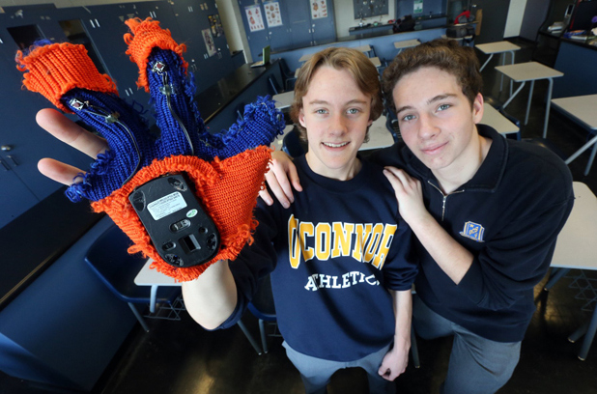The results? ‘(Test subjects) said it was less painful than a regular mouse, and the actual mousing ability was easy. We asked if they would buy it for $10, that was our cost to make it,’ said Simon. (Some 95 per cent said they would.)

‘The amazing thing it does, especially with games, is make you feel more immersed in the game,’ said Charlie, adding they are thinking of improvements to their design, including a cooler material so hands don’t get sweaty.

*Source:* [*metronews.ca*](http://metronews.ca/news/toronto/1343828/mouse-glove-shocket-among-toronto-science-fair-innovations/)

# Complete the following table.

|  |  |
| --- | --- |
| **Problem** | Whit a normal mouse you can get an injury on your small muscles in your wrist |
| **Hypothesis** | movement is coming from the elbow and shoulder and could reduce repetitive strain injury |
| **Materials needed** | Base of a regular mouse that have a wireless adaptor, socks form their hockey theme, buttons from an old cd player,  __________________________________________________ |
| **Procedure** | __________________________________________________ __________________________________________________ |
| **Conclusion** | The mouse is less painful than a regular mouse because you do not have to use your fingers to much so there is less chance to get an injury on your muscles in your wrist |

# True or false? Justify your answer each time.

|  |  |  |
| --- | --- | --- |
| **Statement** | **True** | **False** |
| Carlie and Simon play games on the computer a lot.  They work a lot on the computer not specifically gaming |  | x |
| A repetitive strain injury is a sort of pain anyone using a computer mouse can get.  Yes because you do the same activity all the time | x |  |
| Carlie and Simon immediately came up with the design shown at the science fair.  After a time they thought why don’t we chance the design |  | x |
| Carlie and Simon asked $10 for their invention.  They ask $10 for buying a mouse |  | x |
| The boys are even thinking about an upgrade of their product.  They are thinking to make the design from another material so your hand could get less sweaty | x |  |